**Events Platform Manual**

**PaySchools Events/ Local Level Events**

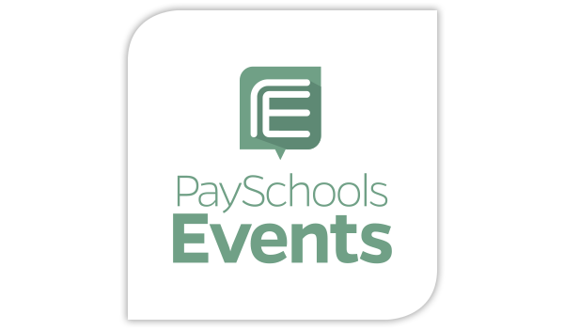



Contents

**How to create an account** 3

**How to Create an Event** 4

# **How to create an account**

Step 1🡪 Go to your provider’s website   
  
If using Local level events use this website🡪 <https://www.locallevelevents.com/users/login>   
If using Local level events use this website 🡪 <https://www.payschoolsevents.com/users/login>

Step 2🡪 Click on create account

Step 3🡪 Fill out the information (First Name, Last Name, etc..) and make sure that the preference is set to creating events and select your domain

# **How to Create an Event**